Modelled Reading- Analysing a text

Adopt-a-Dog
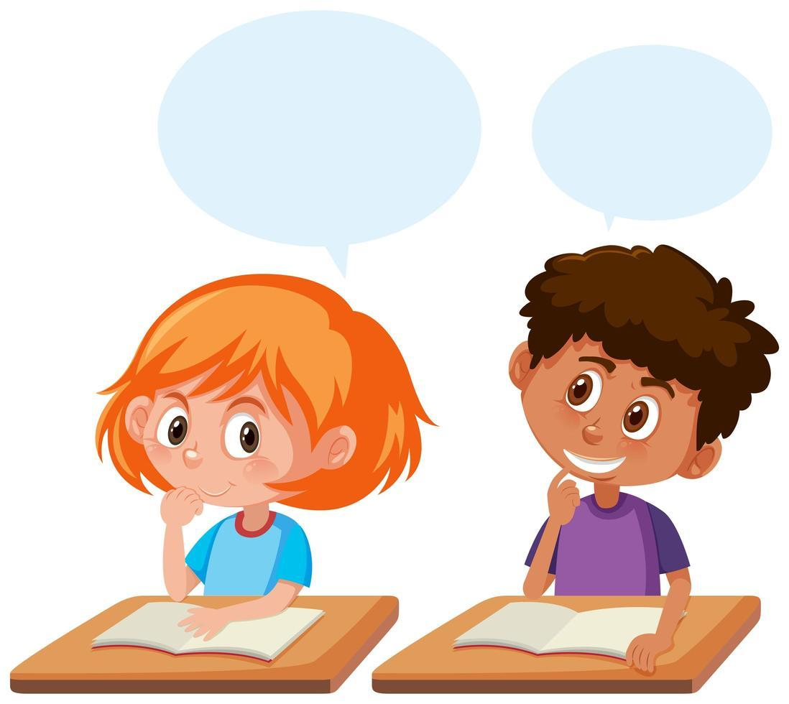
Important: Watch the video link in your timetable to see Ms Noonan explain this lesson in detail.

Today, we are practising analysing a whole text to understand the main idea of what we have read.

There are three parts to this activity:
- Read the text below
- Read the text a second time and highlight the important information. (You can either print the lesson out and highlight with a highlighter or use the highlighter tool on the tool bar above. It should look something like this

- Look at the information you have highlighted to help you fill in the table below.

Adopt-a-Dog
Adopt-a-Dog,
0898761234
adoptadog@dogmail.com

Candy
Size: small
Breed: Australian Terrier cross
Colour: black, white and tan
Age: four years old
Personality: gentle

Candy is a fun-loving dog who could come home with you straightaway-or in two wags of a tail. She is a much-loved pet but sadly, her family has moved overseas. Candy is now searching for a new family. Could Candy be the perfect pet you are looking for?

The Evans family found their perfect pet last year when they adopted a Labrador. Here’s what they said: “We love Rocky. He is really part of our family. He loves to be walked and to play with the kids.”

At Adopt-a-Dog we know that each of our furry friends will make a great addition to your family. Kids, are you having trouble convincing your parents? Tell them that Candy is friendlier than a cat, more interesting than a fish and cheaper to feed than a pony. And if you are lucky enough to take Candy home, you can even start using the excuse, “The dog ate my homework!’
We are proud to say that Adopt-a-Dog has helped more than fifty dogs to find a home this year. All our dogs have been to the vet so they are desexed, microchipped, vaccinated and wormed.

***You can adopt Candy now for three hundred dollars***.

You would have to be barking mad to miss out.

Candy has our full four paws of approval!
Year 3 NAPLAN Reading Magazine, 2014 ACARA
Key Vocabulary |  | Repeated vocabulary
Detail | Detail |  | Detail
Main Idea (1 sentence only)

